

Mathematics Applications
YEAR 12

Investigation 2 – Pascal’s Networks

Semester 1 2018

Time allowed: One week (In-Class assessment Friday Week 6)

Marks Available: This section will not be marked. Research only

Task:
Research and familiarise yourself with Pascal’s Triangle focusing on its formation and patterns.

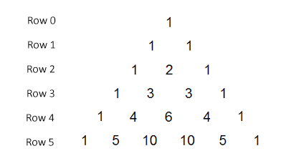

The In-class assessment will be conducted ‘note-free’. No research may be taken into this assessment. You will be able to utilise a scientific calculator only during the assessment; A ClassPad will not be allowed.

